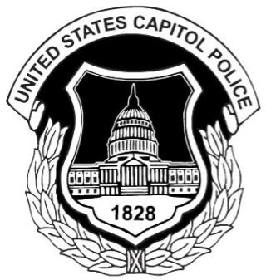
UNITED STATES CAPITOL POLICE
LABOR COMMITTEE
ATTENTION ALL MEMBERS
General Membership Meeting
_________________________________________________________________________________________________________________________________
DATE & LOCATION
June 1, 2017
1900 hours
Cannon House Office Building Room # 122
_________________________________________________________________________________________________________________________________
AGENDA
- Vote on Proposed Changes in the By-Laws

_______________________________________________________________________________________________________________________________

Disclaimer: In an effort to ensure full compliance with Department policy and directives it is imperative that all Officers refrain from conducting Union business while utilizing department resources.

